Ideation Phase
Empathize & Discover

Date | 18 Feb 2026
Team ID | LTVIP2026TMIDS80588
Project Name | TransLingua: AI-Powered Multi-Language Translator
Maximum Marks | 4 Marks

Empathy Map Canvas:
An empathy map is a simple, easy-to-digest visual that captures knowledge about a user’s behaviours and attitudes.

It is a useful tool to helps teams better understand their users.
Creating an effective solution requires understanding the true problem and the person who is experiencing it. The exercise of creating the map helps participants consider things from the user’s perspective along with his or her goals and challenges.
Example:
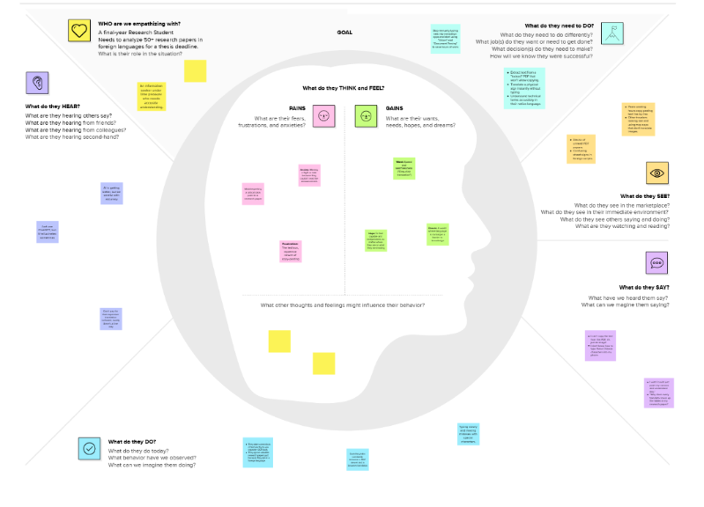

Reference: https://app.mural.co/t/smartbridge4281/m/smartbridge4281/1771407907284/ac241ce564045918e5ef8ba15b611cd04a33373c?sender=uff685125f1d79c981e733450

Example: Food Ordering & Delivery Application


